High Dimension Visualization: t-SNE

- t-SNE stands for t-distributed Stochastic Neighborhood Embedding which was presented by Laurens van der Maaten and Geoffrey Hinton in 2008.
- One of the limitations of PCA is that it does not preserve the neighborhood when points are projected from a higher dimension to a lower dimension.

- If one wants to project data from a higher dimension to a lower dimension, t-SNE will try to preserve the distances of the points that are close to each other.
- t-SNE tries to create an embedding that preserves the neighborhood using some probabilistic methods.

- Hence, the core idea behind t-SNE is;
  - When we go from 𝑑-dimensions to 𝑑′-dimensions where 𝑑<𝑑′, the core idea behind t-SNE is to preserve the pairwise distance in a neighborhood as best as possible.
- But, there is a problem that t-SNE faces while preserving neighborhood information. It is known as The Crowding Problem.

Crowding Problem

- Suppose we have 2D data and we want to project it in 1D data using any neighborhood embedding method.
- We have four data points in the shape of a square, where 𝑎 is at the origin, 𝑏 is on X-axis, and 𝑑 is on Y-axis as shown in the diagram given below.
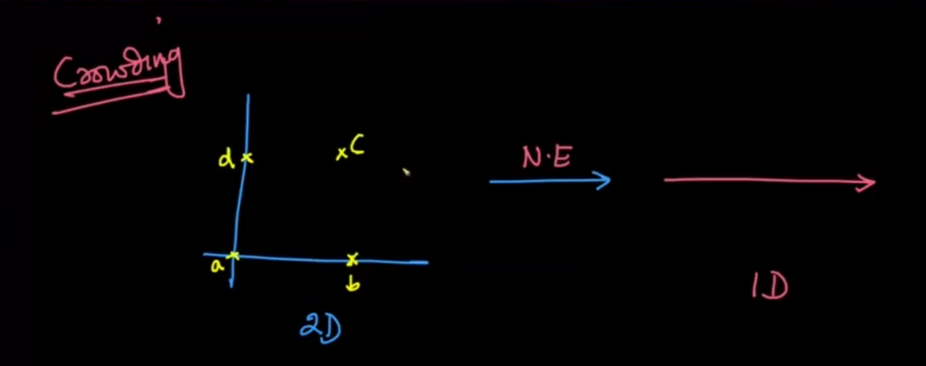

- Now, consider a case, when we choose the neighborhood of the point 𝑎 that contains all the other points.
Let's try to project this data into 1D such that the pairwise distance is preserved
- We place point 𝑎 on a 1D axis, point 𝑏 on the right of point 𝑎, and point 𝑑 on the left of point 𝑎. Here, the distance of both the points 𝑑 and 𝑏 to point 𝑎 is the same.
- Now, if you try to project point 𝑐, it will be exactly projected at the coordinates of point 𝑎. Because, as 𝑎 is equidistant from point 𝑏 and 𝑑, so is the point 𝑐.
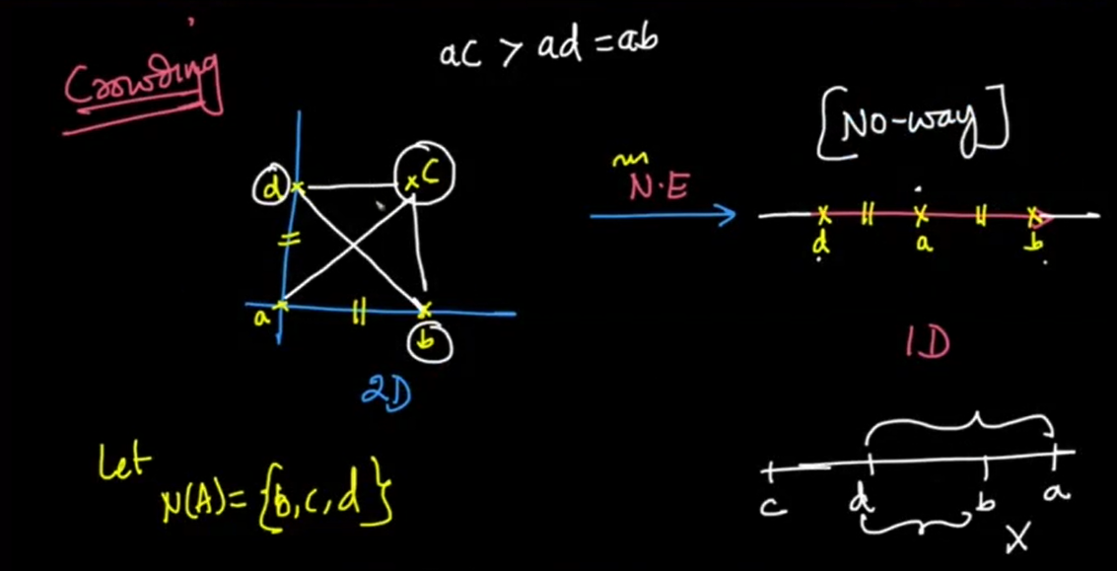

- This was just a simple case we saw for better understanding.
- In real-life data, there will be hundreds, probably thousands of points that will not be able to preserve pairwise distance when projected from a higher dimension to a lower dimension

Math for t-SNE

- Our objective is to project datapoints 𝑥𝑖 ∈ 𝑅^{𝑑} to 𝑦_{𝑖} using t-SNE, where 𝑦_{𝑖} ∈ 𝑅²
- In t-SNE, we compute the pairwise similarities as probabilities.
- We compute 𝑃_{𝑖𝑗} for 𝑑-dimensions and 𝑄_{𝑖𝑗} for 𝑑′-dimensions where 𝑑>𝑑′
- 𝑃_{𝑖𝑗} is the probability that the points 𝑥_{𝑖} and 𝑥_{𝑗} are neighbors in 𝑑-dimensional space.
- The pairwise similarities in the low-dimensional map 𝑄_{𝑖𝑗} are given by:
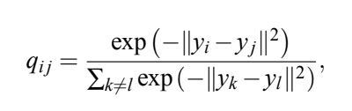

- The pairwise similarities in the high-dimensional space 𝑃_{𝑖𝑗} is:

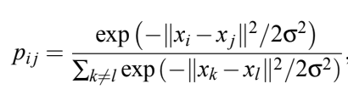

- As you can see in the equation above, the numerator term in 𝑃_{𝑖𝑗} is nothing but a sort of normal distribution with a variance of σ.
  - The term |𝑥_{𝑖}−𝑥_{𝑗}|² computes the euclidean distance between 𝑥_{𝑖} and 𝑥_{𝑗}.
  - As 𝑥_{𝑖} and 𝑥_{𝑗} move farther and farther away, we give the lower probability that 𝑥_{𝑖} and 𝑥_{𝑗} are neighbors
- Now, as we are computing probabilities, probabilities across all points should be equal to 1
- So, the denominator terms is just a normalization factor to make sure that sum of all the probabilities is equal to 1
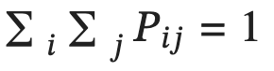

- This technique is known as SNE.

- Now, in 𝑑′-dimensions space, every 𝑥_{𝑖} and 𝑥_{𝑗} would have corresponding 𝑦_{𝑖} and 𝑦_{𝑗}.
- So, again we define 𝑄_{𝑖𝑗} with the same formulation as 𝑃_{𝑖𝑗}
- Hence, if 𝑥_{𝑖} and 𝑥_{𝑗} are similar, then 𝑃_{𝑖𝑗} would be higher and we want our 𝑦_{𝑖} and 𝑦_{𝑗} such a representation such that 𝑄_{𝑖𝑗} is also high.
- Because of the crowding problem, we can never perfectly preserve the distance.
- So, in t-SNE, we try to preserve the probabilities when going from high dimension to low dimension space
- We compare probabilities 𝑃_{𝑖𝑗} and 𝑄_{𝑖𝑗} with something known as KL-Divergence.

KL-Divergence

- It measures the dissimilarity between the distributions.
- So, the KL-Divergence between two distributions 𝑃 and 𝑄 can be written as:
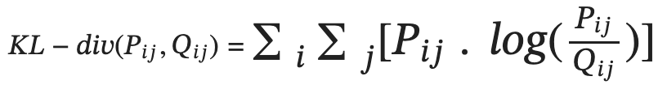
- KL-divergence is also known as relative entropy.

Interpreting KL-Divergence

- If 𝑃_{𝑖𝑗} and 𝑄_{𝑖𝑗} are the same, then KL-divergence will be equal to 0.
- If 𝑃_{𝑖𝑗} is very small and, 𝑃_{𝑖𝑗} and 𝑄_{𝑖𝑗} are the same, then KL-divergence will have a small value.
  - Think of 𝑃_{𝑖𝑗} working as a weightage, because if 𝑃_{𝑖𝑗} is small we don't really care as points 𝑥𝑖 and 𝑥𝑗 will be far away from each other in d-dimension space.
- So, now our optimization problem would be to find all the 𝑦_{𝑖}s that minimize KL-divergence(P, Q)
- Lastly, since KL-divergence is a measure of dissimilarity, it is always greater than or equal to 0.

‘t’ in t-SNE

- For computing 𝑃_{𝑖𝑗}, we used gaussian like function.
- But, it was found that if we compute 𝑃_{𝑖𝑗} using t-distribution with 1 degree of freedom, the results were better.
- t-distributions with 𝑑𝑜𝑓=1 have longer tails than gaussian distributions
- Gaussian distribution falls exponentially while t-distributions sort of inversely
- So, for our 𝑄𝑖𝑗s, if we start using t-distribution, two points can go farther away and still get pairwise distance preserved of sort
- Meaning, in t-SNE, we use Gaussian distribution for 𝑃_{𝑖𝑗}s and t-distribution for 𝑄_{𝑖𝑗}s because of which if two points are far away in lower dimensional space, the probabilities will still remain the same
- Now, If we increase 𝑑𝑜𝑓 and keep increasing, it will behave like a gaussian distribution which will face the problem of crowding
- At, 𝑑𝑜𝑓=∞, it behaves very similar to a Gaussian distribution
- t-distribution with 𝑑𝑜𝑓=1 is also known as Cauchy Distribution

Perplexity
- Perplexity is one of the most parameters that you might want to configure when using t-SNE.
- Perplexity can be interpreted as the effective number of neighbors whose distance we want to preserve
- Typically, we keep the value between [5,50]
- The optimization of t-SNE is very time taking as there are no single optima.
- Also, if you add a bunch of newer data points to the dataset, you won't get projections into lower dimensional space automatically.
- You would have to fit the t-SNE model again on the whole dataset again.

Use this blog to play around with t-SNE on different data distributions: https://distill.pub/2016/misread-tsne/

